Lightweight Remote Invocation Framework

# Directory Structure

SIRF

Client

bin

Client.class

Contract

Task.class

CSMessage.class

CalculatePi.class

CalculateGCD.class

CalculatePrime.class

Server

bin

FileServer.class

ObjectServer.class

Contract

Task.class

CSMessage.class

# Step up

1. Open Client and Server Projects in eclipse.
2. To start server, execute FileServer.class. It starts server socket for file upload on port 6790 and for object retrival on port 6789.

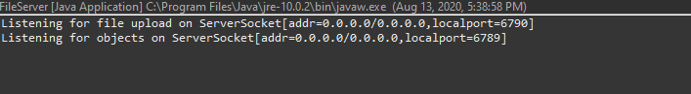

1. To start GUI, execute Client.class.

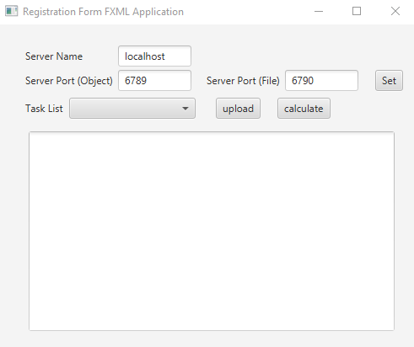

# Contracts

1. Initial Contracts on server side.

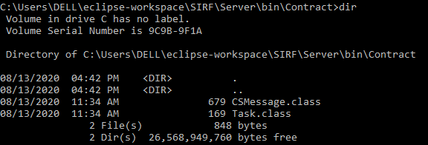

1. Initial Contracts on client side.

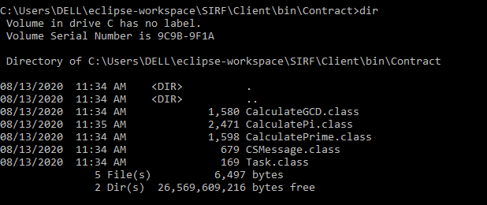

# Execution

## Class File Upload

Select File from Dropdown task List and click upload. The class file will be uploaded to the Contract folder at server side.

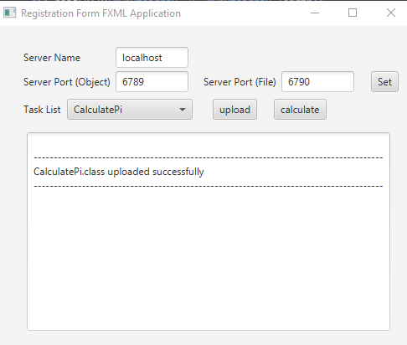

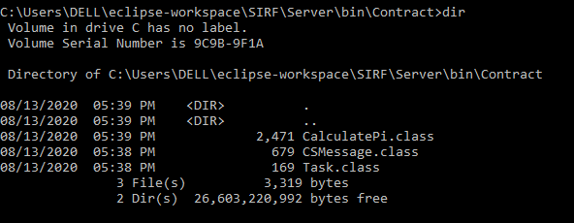

## Object Execution

Select Task from task list and click calculate. A dialog box will appear asking for inputs required. The task will be executed on server and displayed on client.

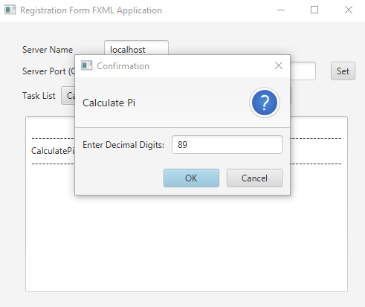 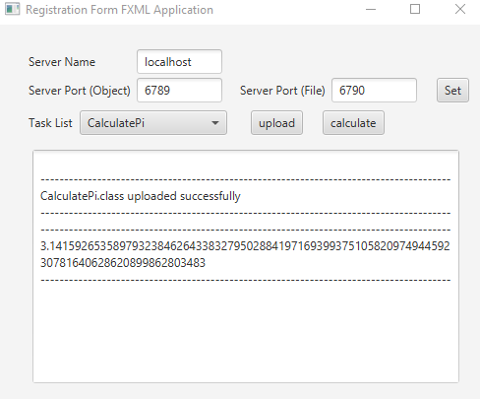

## Exceptions

If task is calculated without uploading class file. An exception will be displayed on client.

Here, an attempt is made to calculate GCD without uploading class file.

